CAMP RULES

The aims of these rules are to keep everyone safe, to give you time to consider many life-changing ideas you will encounter at this camp, to hear God’s own voice to you, and to not distract others from these pursuits in the few days we have here.

- Follow the schedule and be on time. Arrive at the camp by 5:30 PM on June 1; latecomers will NOT be admitted. You must attend all classes during the camp.
- Be in your own assigned cabin from 9:50PM to 7AM.
- No guys in gals’ rooms or gals in guys’ rooms.
- For your safety and others’ sakes, do not leave the camp area—by yourself or with anyone else—except with permission from the camp superintendent.
- Be kind. Do not rough-house or play roughly. Proverbs 26:18-19.
- Use of personal entertainment devices is prohibited. This includes music player, video player, laptop, tablet, video game, camera, e-reader, or other such devices. E-mail will not be available to campers during the camp.
- It is best not to bring a cell phone but one may be brought subject to these severe restrictions: Use it only to talk with parents to let them know you safely arrive or are departing, or to people providing your ride. After arrival, mark a phone and any other electronic device with your name, power it off, and turn it in and sign it in at the registration desk.
- Campers are not permitted to drive even their own cars during the camp period, except with permission from the camp superintendent.
- Please dress modestly to glorify our Lord and to avoid unnecessary temptations. Guys’ shorts must cover the knee. Girls can wear Capris, pants, or skirts, but these must cover the knee. Tank-top and spaghetti straps are not allowed. Midsection and cleavage are not to be exposed in any way. Flipflops are not allowed in class for guys or girls. Swimwear for guys is boxer-style swimming trunks. Swimwear for girls is one piece only. Activities may be denied until appropriate clothing is worn.
- Guys’ hair should not touch their shirt collar or cover their ear. Earrings and piercing are not permitted for guys.
- Campers are permitted to swim or boat only as a scheduled group activity.
- Your group leaders have invested an enormous amount of time and have made sacrifices for your sake because of their love for God. Please make their job a joy: submit to the group counselors and leaders as they lead this camp.
- Please take care of the camp property. It is the property of God. Please clean your feet before you enter the building. Keep the walls and carpet in their original condition.
- Please be faithful in all your assigned duties, such as dish washing and cleaning.
- You are encouraged to bring your musical instruments to CWC (You may use them for worship and mission trips).

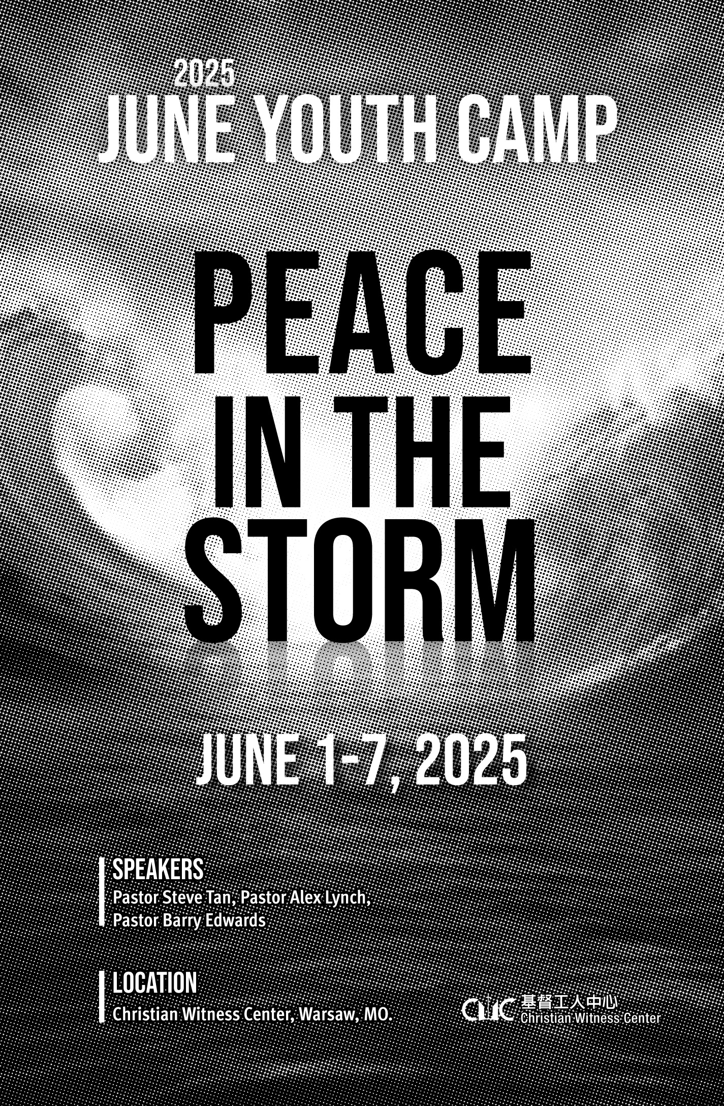
Date:  CWC YOUTH CAMP  2002 | June 1 Dinner (5:30pm) – June 7 Lunch (1pm), 2025  FULL-TIME attendance is required.
Location: | Christian Witness Center  29752 Aloha Dr. Edwards, MO. 65326
Speakers: | Pastor Steve Tan – Senior pastor at the Emmanuel Chinese  Baptist Church (Overland Park, KS)  Pastor Alex – Pastor at the Countryside Church (Overland Park,  KS)  Pastor Barry Edwards – Senior Pastor at the Cedar Grove  Baptist Church (Warsaw, MO)
 | Build future youth leaders and transform them to be disciples of Christ. For believers aged 12 (entering the 7th grade after summer) to college age.
Activities: | Sports, Boating, Pontoon, Rafting and Camp Fire.
Fee: | $155 (No camp t-shirt this year)  $25 rafting fee (an optional activity expense)
Bring: | Bible, notebook, personal needs, sleeping bag and sheet, swimming suit/trunks, towel, etc.
Apply: | Complete the application form and mail it with a check payable to CWC to Mrs. Yu Mu (1706 Sun Ct, Columbia, MO 65201).  Or pay the fee via Zelle (pls. check cwcnet.org/site/?p=3634 for detailed instructions) and then email the form to Mrs. Yu Mu (yumuliang@gmail.com) with the Zelle confirmation #.  The strict deadline is May 28, 2025.
Web: | www.cwcnet.org, E-mail: cwc@cwcnet.org
Language: | English
Contact: | Yu Mu (about Registration) 607-727-3621  Leon Chen (about the Camp) mktchen@gmail.com, 859-420-3636  Sister Cindy Chiang (any other questions) 660-438-7710  During the Camp, pls. contact 660-438-7710, cwc@cwcnet.org

TOPICS FOR DISCIPLESHIP AND WORKSHOP
DISCIPLESHIP:  1. Discipline of Godliness  2. Discipline of Purity  3. Living Out Our Faith  4. Abide in God's Word  5. Be Transformed  6. The Power of Worship | WORKSHOPS:  1. How Does Abiding in Christ Shape Our Identity in Today’s World?  2. Standing Firm in Faith Amid Cultural Shifts  3. Healthy Relationships from a Biblical Perspective  4. How to Share the Gospel with Confidence
DAILY SCHEDULE

 | 6/1  SUN | 6/2  MON | 6/3  TUE | 6/4  WED | 6/5  THU | 6/6  FRI | 6/7  SAT
7:00-7:55 | Welcome to CWC | Arise/Personal Devotions
7:55-8:30 | Welcome to CWC | Group Devotions
8:30-9:10 | Welcome to CWC | Breakfast
9:15-9:30 | Welcome to CWC | Praise and Worship
9:30-10:20 | Welcome to CWC | Discipleship Message
10:30-11:20 | Welcome to CWC | Morning Workshop
11:30-12:15 | Welcome to CWC | Group Discussion |  |  | Canoe Trip | Group Discussion
12:15-1:15 | Welcome to CWC | Lunch |  |  | Canoe Trip | Lunch
1:20-2:20 | Welcome to CWC | Quiet Time |  | Mission Trips | Canoe Trip | Quiet Time | See You Next Year
2:30-3:20 | Welcome to CWC | Afternoon Workshop |  | Mission Trips | Canoe Trip | CWC Got Talents | See You Next Year
3:30-4:30 | Welcome to CWC | Mission Project
4:40-5:30 | Welcome to CWC | Organized Activities |  | Mission Trips | Canoe Trip | Free Time | See You Next Year
5:30-7:00 | Supper |  |  | Mission Trips | Canoe Trip | Supper | See You Next Year
7:00-7:20 | Praise and Worship |  |  | Mission Trips | Canoe Trip | Praise & Worship | See You Next Year
7:20-8:10 | Evening Message |  |  | Mission Trips | Evening Message |  | See You Next Year
8:10-8:30 | Prayer & Announcements (P&A) |  |  | Mission Trips | P&A |  | See You Next Year
8:30-9:00 | Snack Time |  |  |  |  | Campfire | See You Next Year
9:15-9:50 | Cabin Sharing And Praying |  |  |  |  | Campfire | See You Next Year
9:50-10:20 | Wash-Up (Stay in your cabin) |  |  |  |  |  | See You Next Year
10:30 | Lights Out |  |  |  |  |  | See You Next Year

2025 CWC YOUTH DISCIPLESHIP TRAINING CAMP APPLICATION FORM
(Make copies as needed)
Last Name: | First Name: |  | Gender: Male Female
Phone: ( ) | Youth’s e-mail: |  | Grade (the grade you will ENTER after summer):  College:
Address:
Father’s name:  Mother’s name: | Parents’ e-mail:
Father’s name:  Mother’s name: | Parents’ phone number:
Guitars, bass, keyboards, trumpets, violins & such will be used during worship, mission trips, and on Friday, where you will have the opportunity to learn how to serve the Lord with these instruments. If you have any of these instruments, and are willing to bring them during the camp, please name of the instrument you would bring: ____________________
- When did you receive Jesus as your Savior? Briefly write down your testimony.

- What are your hopes for this year’s CWC Youth Discipleship Training Camp
For example: learn more of what I should do with my life, become less self-centered, become more loving, answer my questions about God, serve God, help people become Jesus’ followers, become a better Christian leader, learn what foundations Christian beliefs have, etc.

RELEASE FORM (For Youth Only)
Please provide information about any medical history

I permit my child (children) to participate in the CWC Youth Discipleship Camp.
Emergency Phone Number: ( ) |  | Work Number: ( )
Name of Legal Guardian:
Legal Guardian Signature: |  | Date:
Continue to next page

Christian Witness Center Youth Discipleship Training Camp Rafting Trip

June 5, 2025

We,_____________________ give permission for_______________________________________________
(print parent's name) (print child’s name or children's names)

to go to the rafting trip with the CWC Discipleship Youth Training Camp.

The group will depart on June 5, 2025, and will return to the CWC camp site in the evening on the same day. The group will float from Ft. Niangua Riverfront in Lebanon, MO (417) 588-3386 (See www.riverfrontcampcanoe.com).

We understand that CWC and the leaders will take reasonable precautions and supervision of the teens throughout the trip. However, just like any outdoor activities, we also understand that risk is involved.

Disclaimer

We will hold harmless the CWC and the leaders for any accidents or injury to our child or children during the trip.

We also give permission to the leaders to sign a release when required for rafting rental and/or use of the campground facilities.

__________________________ ____________________
Parent's signature Date

